**My Passion Project**

My Passion Project is Designing and building a mobile app, which is my interest and hobby. Looking into the different categories of mobile apps, such as productivity, health and fitness, social networking, gaming, education, or entertainment. The category which resonates with me the most and align with my passions is that of education.

Considering the problems and challenges that people face in education especially children, educational mobile app would help solve those problems or enhance their experiences. However for the passion I have for mobile app development, I tried to learn, practice and Google has published four (4) of my apps which are: <https://play.google.com/store/apps/details?id=com.wPrincofishgame_16999854> , <https://play.google.com/store/apps/details?id=com.wWordSearchLegend_17034643>, <https://play.google.com/store/apps/details?id=com.wMatchPuzzle_17047792&pli=1> and <https://play.google.com/store/apps/details?id=com.wXPhotoEditor_17055167&pli=1>. Which are games and a photo editor. Here are some of my mobile app screenshots

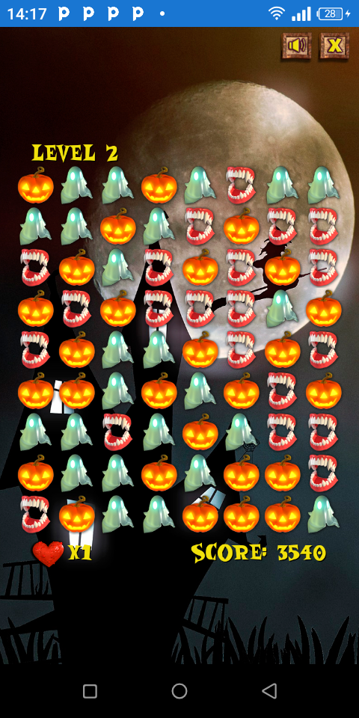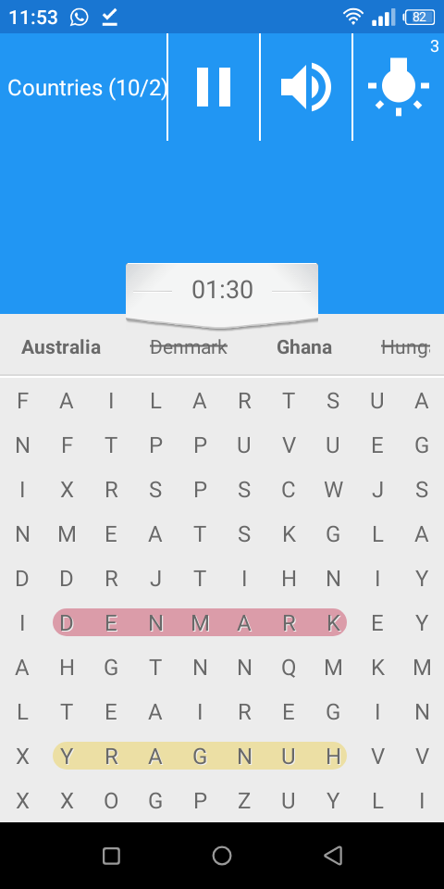

I would like to design and build and educative app where children from lower level to the upper level to gain access to all teaching and learning materials with pictures and practical modules especially in technology as we are now in the technology world. The app would be conducted thorough testing to ensure usability, functionality and compatibility across different devices and browsers to identify and fix any bugs or issues.

The app would be published on some of the social media platforms for users to get access to it and also regular update and maintenance of the app to ensure security, performance, and feature enhancements.

In conclusion, I am sure my Passion Project would be successful.